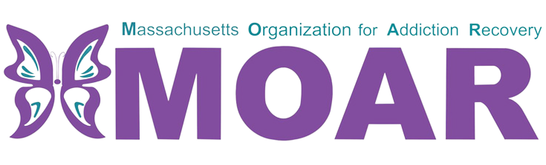

Central MA Opioids Fact Sheet
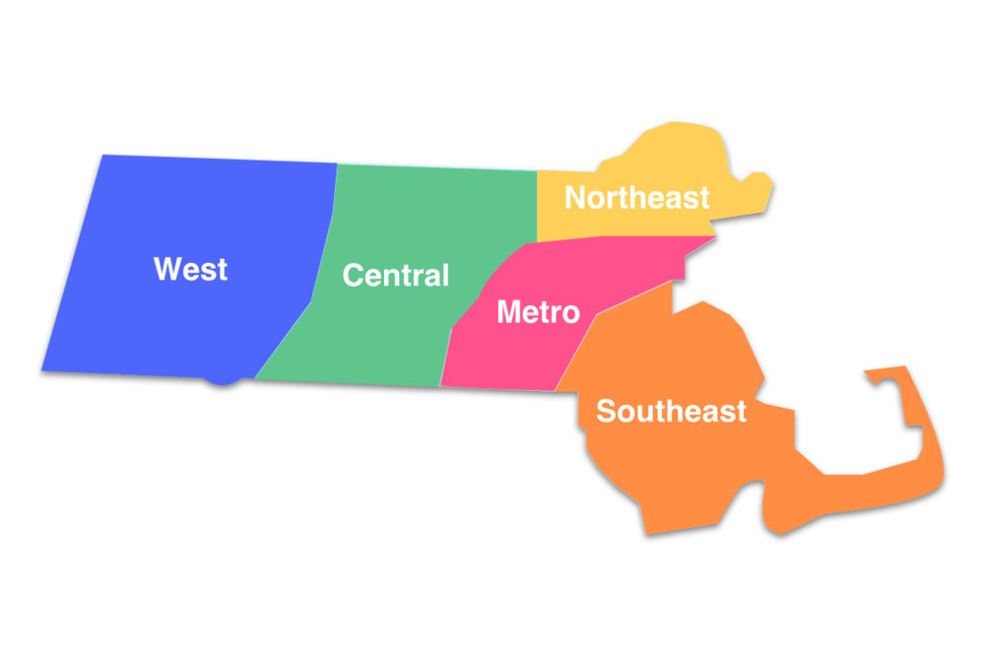

What are opioids?

Opioids are a type of drug that is prescribed to reduce pain. The frequent use of opioids can lead to developing tolerance and dependence.

In 2021, the total number of confirmed opioid-related overdose deaths per county were 282 in Worcester.

City/Town  across  Central MA | Total opioid-related overdose deaths (2020) | Total opioid-related overdose deaths (2021)
Worcester | 103 | 105
Holden | 2 | 3
Gardner | 4 | 11
Dudley | 1 | 5
Milford | 2 | 9
Spencer | 2 | 4
Rutland | 1 | 5
Fitchburg | 19 | 17
Leominster | 13 | 12
Westborough | 2 | 0
Webster | 8 | 5
Leicester | 5 | 3
Between 2020 and 2021:
- Worcester, Holden, Gardner, Dudley, Milford, Spencer and Rutland had an increase in opioid-related overdose deaths.
- Fitchburg, Leominster, Westborough, Webster, and Leicester had a decrease in opioid-related overdose deaths.

This fact sheet provides the most recent data on opioid statistics published by Massachusetts Department of Public Health. For more information, please visit the website at
https://www.mass.gov/lists/current-opioid-statistics

What is the current situation in Worcester County?

Between 2020 and 2021, the total number of confirmed opioid-related deaths has remained the same. It has not changed from 282 reported deaths.

