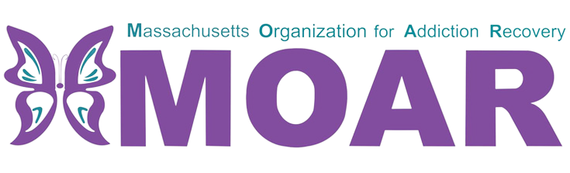

Southeast Opioids Fact Sheet
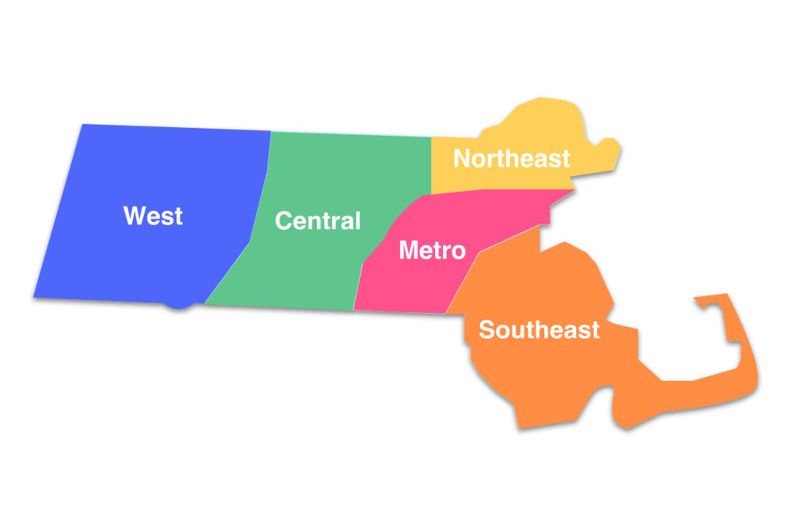

What are opioids?

In 2021, the total number of confirmed opioid-related overdose deaths per county were 79 in Barnstable, 5 in Dukes, 168 in Plymouth, 4 in Nantucket and 290 in Bristol.
Opioids are a type of drug that is prescribed to reduce pain. The frequent use of opioids can lead to developing tolerance and dependence.

City/Town  across  Southeast MA | Total opioid-related overdose deaths (2020) | Total opioid-related overdose deaths (2021)
Brockton | 48 | 56
New Bedford | 64 | 81
Oaks Bluff | 1 | 4
Randolph | 6 | 13
Taunton | 16 | 35
Falmouth | 14 | 20
East Bridgewater | 6 | 3
Marshfield | 9 | 4
Plymouth | 1 | 0
Fall River | 75 | 69
Braintree | 11  Between 2020 and 2021:  - Brockton, New Bedford, Oaks Bluff, Randolph, Taunton, and Falmouth had an increase in opioid-related overdose deaths.  - East Bridgewater, Marshfield, Plymouth, Fall River, and Braintree had a decrease in opioid-related overdose deaths. | 7
What is the current situation in Nantucket County?

In 2021, the total number of confirmed opioid-related deaths was 4. There were 3 more deaths reported compared to the previous year.
This fact sheet provides the most recent data on opioid statistics published by Massachusetts Department of Public Health. For more information, please visit the website at
https://www.mass.gov/lists/current-opioid-statistics

