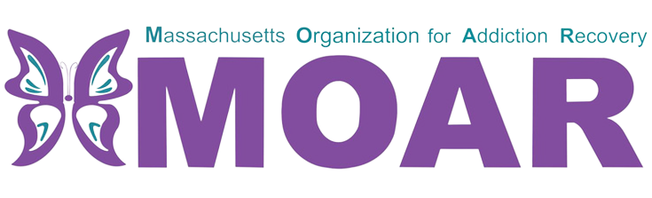

Western MA Opioids Fact Sheet
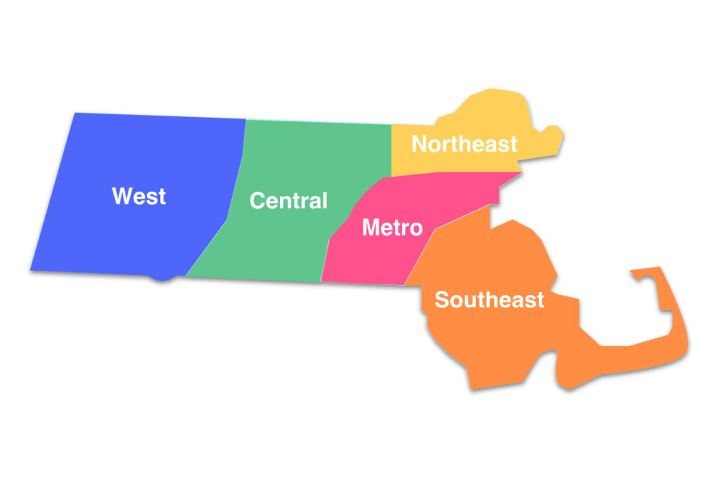

What are opioids?

City/Town  across  Western MA | Total opioid-related overdose deaths (2020) | Total opioid-related overdose deaths (2021)
Chicopee | 35 | 25
North Adams | 13 | 9
Springfield | 89 | 84
Greenfield | 7 | 11
Holyoke | 21 | 23
Northampton | 8 | 11
Pittsfield | 22 | 33
Ware | 3 | 13
Westfield | 8 | 18
In 2021, the total number of confirmed opioid-related overdose deaths per county were 62 in Berkshire, 36 in Franklin, 211 in Hampden, and 44 in Hampshire.

A toxicology report indicated that fentanyl has been present at a 93% rate and it is the driving force behind these deaths.
This fact sheet provides the most recent data on opioid statistics published by Massachusetts Department of Public Health. For more information, please visit the website at
https://www.mass.gov/lists/current-opioid-statistics
Opioids are a type of drug that is prescribed to reduce pain. The frequent use of opioids can lead to developing tolerance and dependence.

What is a factor influencing opioid-related overdose deaths?

Between 2020 and 2021:
- Chicopee, North Adams, and Springfield had a decrease in opioid-related overdose deaths.
- Greenfield, Holyoke, Northampton, Pittsfield, Ware, and Westfield had an increase in opioid-related overdose deaths.

